14.81: The water will rise until the rate at which the water flows out of the hole is the rate at which water is added;

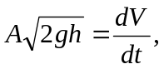

which is solved for

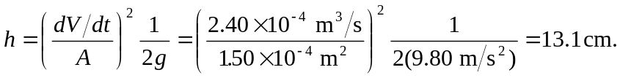

Note that the result is independent of the diameter of the bucket.

